Course Evaluations on-line now, please take a few minutes to fill out. The deadline is December 7th so don’t delay.

Recap of Current Loop Controls:

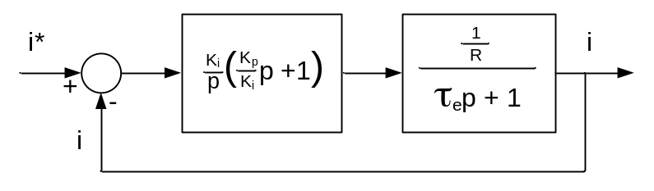
Current Regulation of DC Drive (with Back EMF Decoupled)

Use Proportional plus Integral (PI) Control

G_{c} = K_{p} + = =

The gains to tune the current loop at locked rotor conditions are thus:

and

Note: By using Back EMF decoupling, the desired bandwidth can be achieved at no zero speed conditions as well.

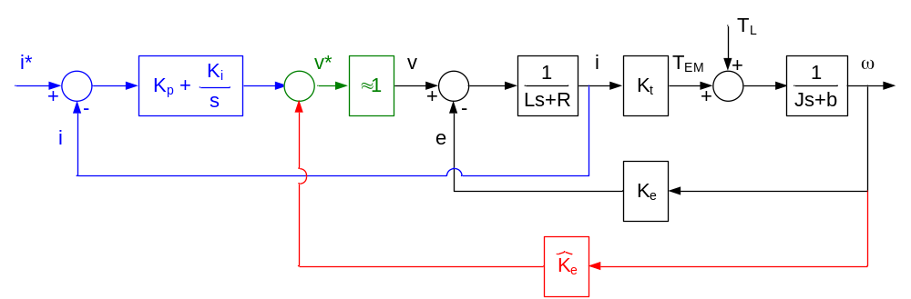
DC Motor PI Current Regulator with Back EMF Decoupling

Induction Machine Current Regulation Tuning:

From last lecture, we can re-write stator voltage equations as:

v = i – j(ω_{e} – ω_{r}) l + j ω_{e} l – _{e} l

v = i + ω_{rb} l

where

r = ω_{rb} =

The scalar equations can be written as:

v = i + σ L_{s} ω_{e} i + ω_{r} λ
v = i – σ L_{s} ω_{e} i – r_{r} λ

In the steady state,

λ = L_{m} i

So the equations can be rewritten as:

v = i + i

v = i – σ L_{s} ω_{e} i – r_{r} i or

v = i – σ L_{s} ω_{e} i

Transient Impedance
Synch Frame Coupling
In summary:
Back EMF

v = i + i

v = i – σ L_{s} ω_{e} i

Voltage control of AC machines

Typical inverter power levels:
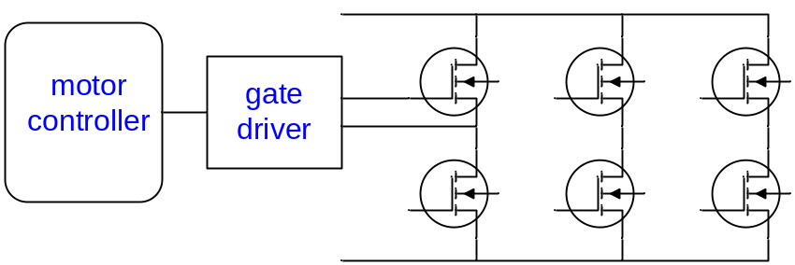
3.3V/100’s mA | +15V/-5V/1-5 Apk | 100’s V/100’s A
Typical Controller Power Sections

Brushless AC (BLAC) Drives:

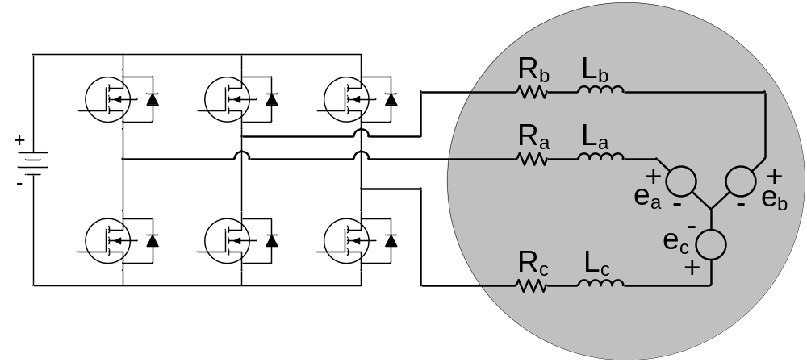
BLDC Drive (Motor and Inverter)

Space Vector PWM:

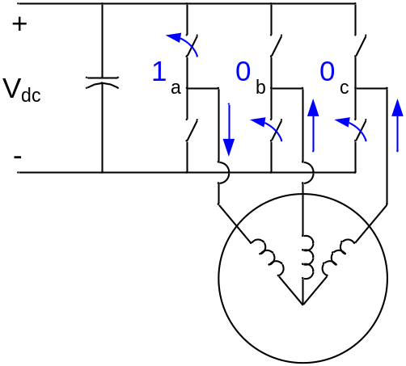 | 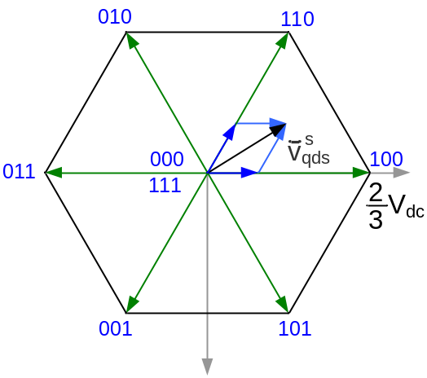
Switching States Used in Space Vector PWM

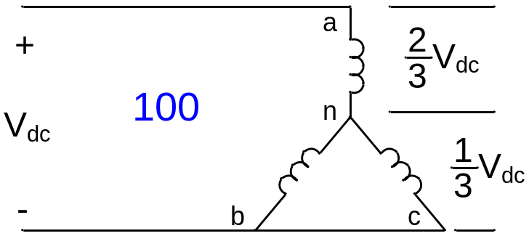 | 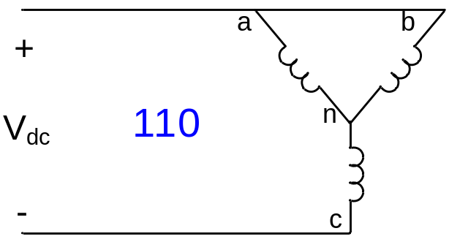
First Two States of Space Vector PWM

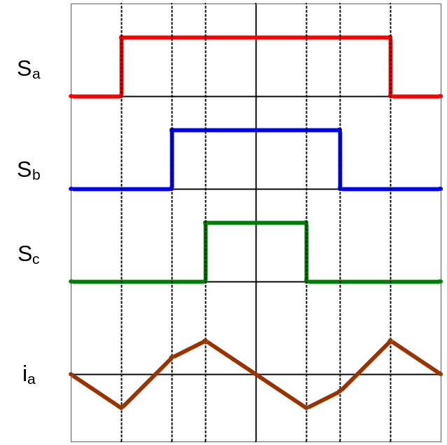
Switching States and Phase Current Ripple in Space Vector PWM Quadrant 1

Direct Torque Control in Induction Machines:

Most common to use stator flux and rotor flux model of induction motor:

p l = l + l + v

p l = l + l

T_{e} = [λ λ - λ λ] = l x l
vector cross product

= |l| |l| sin(∠l - ∠ l)

Observations:

1) Neglecting “i r” drop change in stator flux = applied voltage vector.

2) Torque produced is proportional to angle between stator and rotor flux vectors.

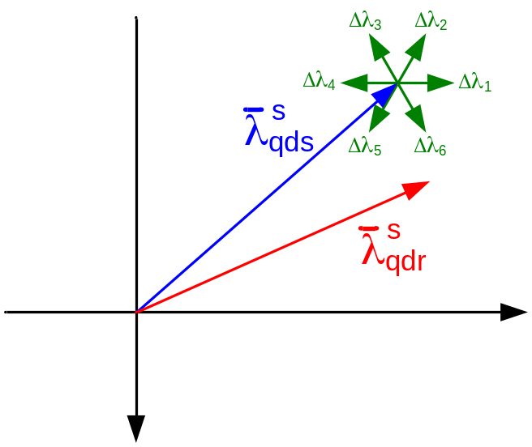
Note: Directly control stator flux linkage by manipulating stator voltage. States 1 and 2 increase stator flux. States 4 and 5 decrease stator flux. States 3 and 6 have minimal change in stator flux magnitude. States 1, 5 and 6 decrease angle between stator and rotor flux. States 2, 3, and 4 increase stator flux.

Vector Plot of Stator and Rotor Flux Linkage Showing Δ Stator Flux Linkage States

PM Synchronous Machine Control
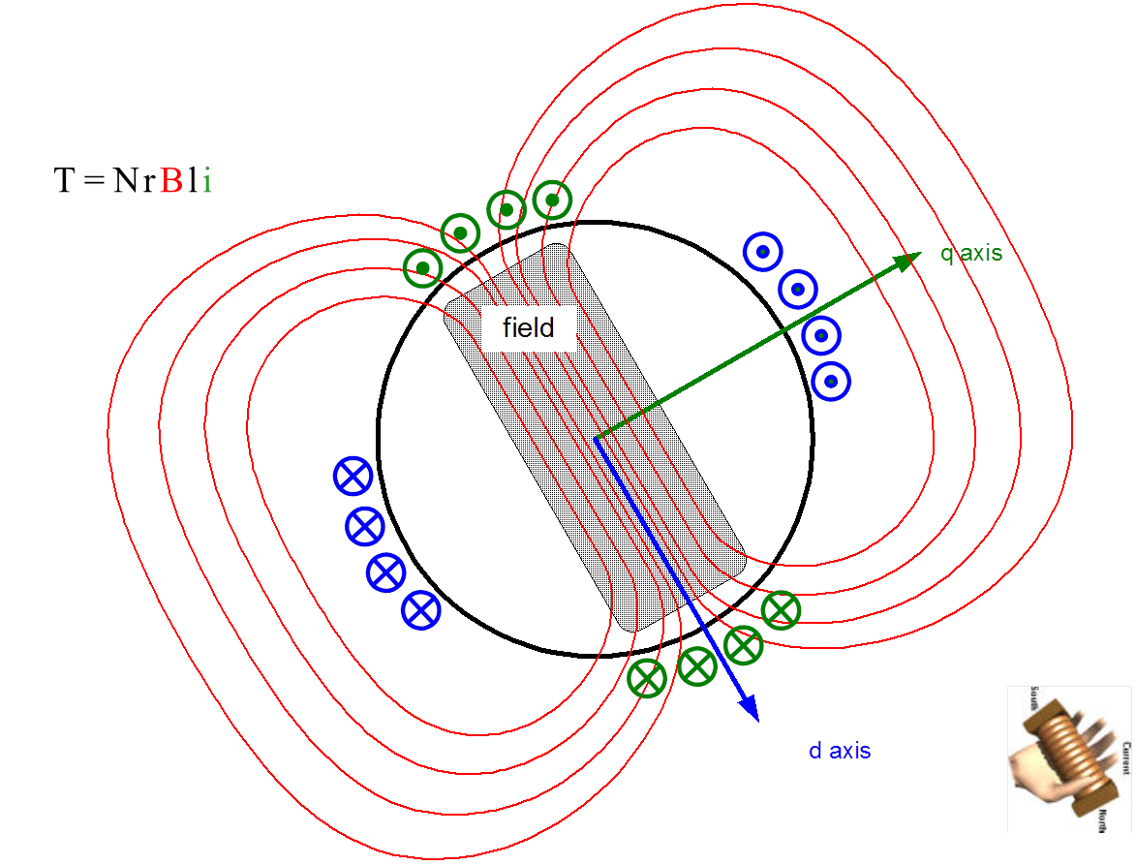

Torque is the interaction of the rotor PM field and the q-axis currents.

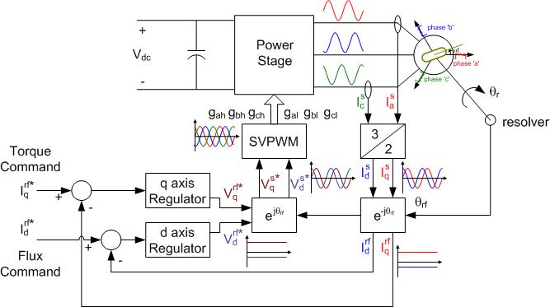

No need for a slip calculator as the PM machine is synchronous with the excitation frequency. The measured rotor position is already in the rotor flux reference frame.

Interior PM Machines

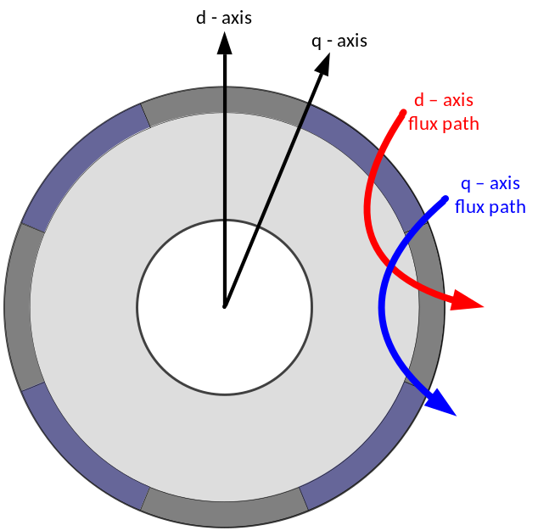 | 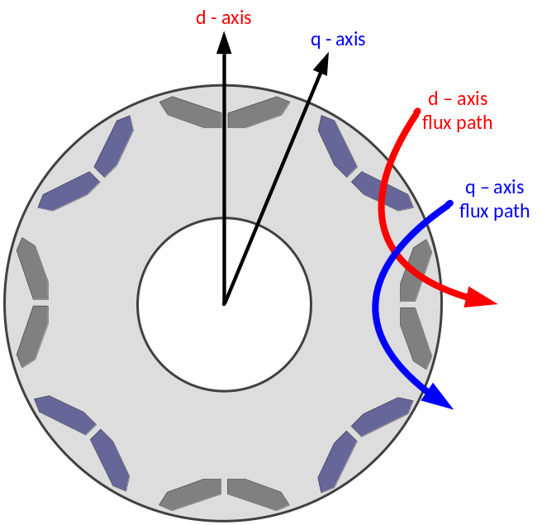
- Surface PM Machine | - Interior PM Machine

Rotor Structure of a Surface PM Machine (a) and Interior PM Machine (b)

v = r_{s} i + + ω λ

v = r_{s} i + – ω λ

λ = L_{ls} i + L_{mq} i

λ = L_{ls} i + L_{md} i + Λ_{mf}

T_{e} = [Λ_{mf} i + (L_{md} – L_{mq}) i i]
PM torque
Reluctance torque

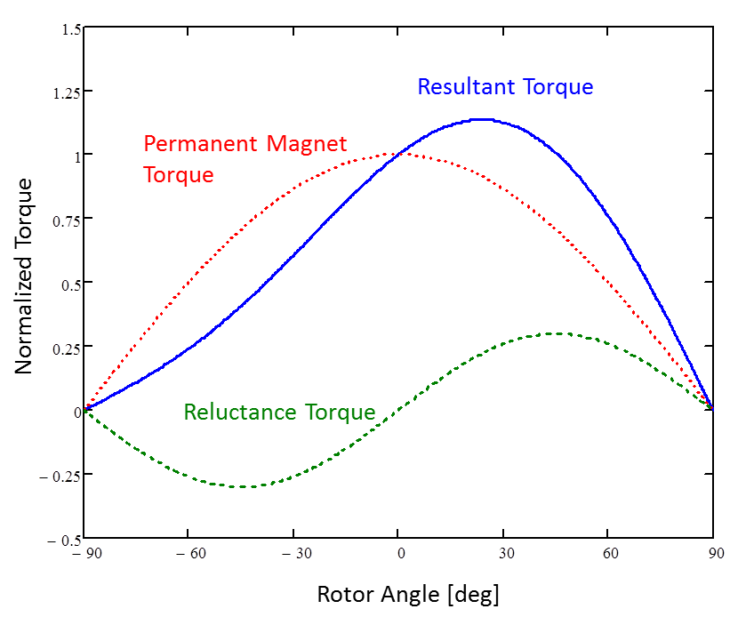
Torque as a Function of Rotor Angle for an Interior Permanent Magnet Machine with Fixed Stator Current

Maximum Current Constraint
i + i = I

Maximum Voltage Constraint
v + v = V

Steady State Operation
v_{qs} = r_{s} i_{qs} + ω λ_{ds}

v_{ds} = r_{s} i_{qs} – ω λ_{qs}

Neglecting IR drop
v_{qs} = ω (L_{ds} i_{ds} + Λ_{mf})

v_{qs} = ω L_{qs} i_{qs}

Voltage limit in terms of currents
(L_{ds} i_{ds} + Λ_{mf})² + (L_{qs} i_{qs})² = = λ_{max}(ω)

Max torque per amp line
_{d}(i_{q}) = -

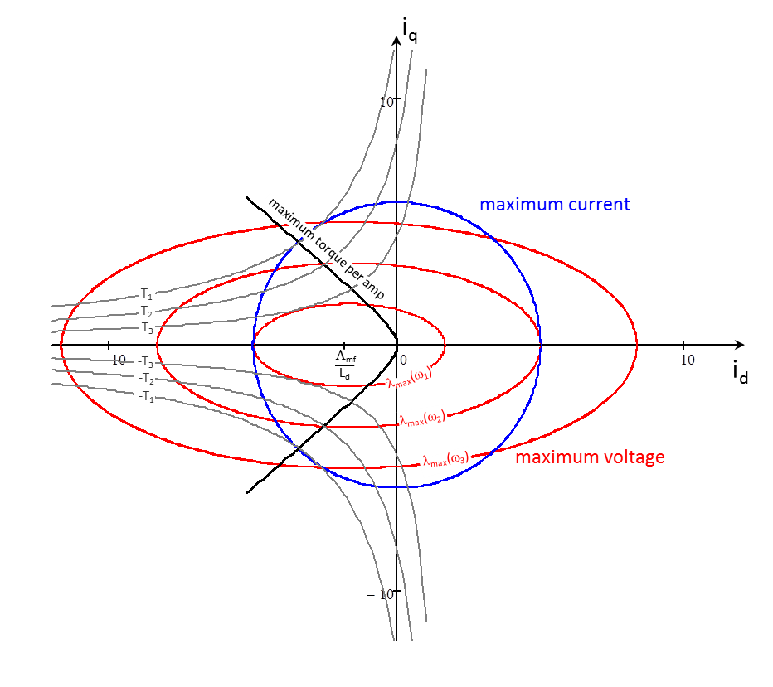
Map of dq Current Plane Showing Maximum Current, Maximum Voltage, Constant Torque Values, and Maximum Torque Per Amp

Speed Control of Machines

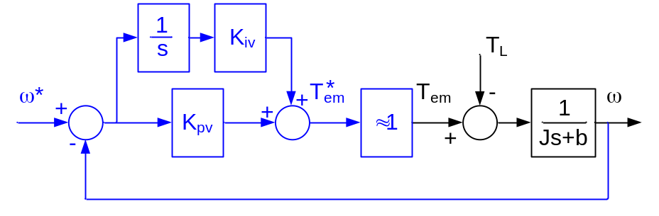
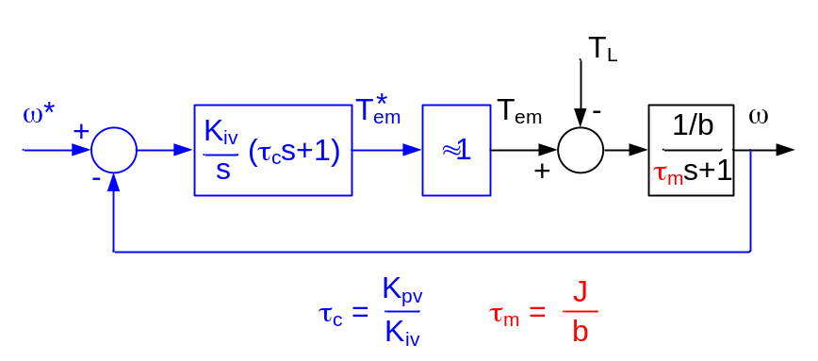
Block Diagram of a DC Machine with Ideal Torque Regulator with a PI Speed Loop (Upper Figure) Rewritten Using Mechanical and Controller Time Constants (Lower Figure)

